SNOW BOARDER

### **Overview:**

**Genre**: Sports, Arcade

**Platform**: PC

### **Gameplay Mechanics:**

### **Snowboarding Adventure**

Player controls a snowboarder navigating downhill slopes.

Responsive controls for turning left and right.

Player can boost speed.

1. **Control**  
   Left and Right arrow key to Tilt

Space to boost (Watch out for boost limit)

1. **Scoring system**

Collect Coin +10points

Flip 360 before landing +20points (Combo x2)

1. **Multiplayer**

You can host to play with your friends.

Compete with friends to collect the most coins and perform the most tricks. Who with highest points will win

1. **Json**

The game will store your highest score in Json file

### **Scene:**

1. **Menu scene:**

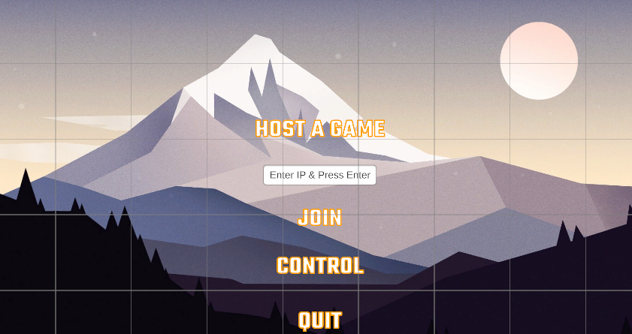  
  
 - Can play with friend or singleplayer

* Host start the game by pressing: “Host a game”
* Client can join with Host’s IPV4
* After player join Host press “Space” to start the game

1. **Game Scene**

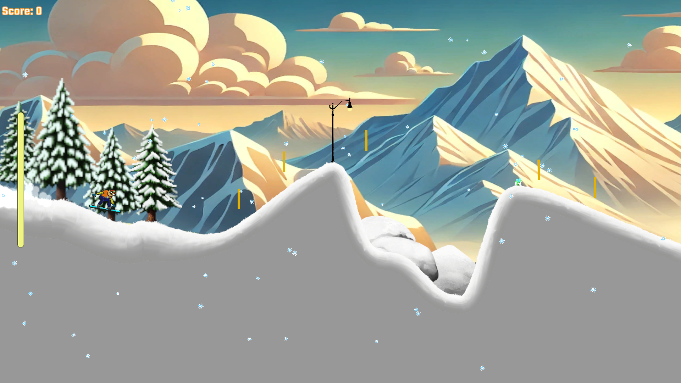

* Boost limit on the right side
* Score on the top-left
* Player pickup coin for point
* Host can pause game with “ESC”